**Manual Test case**

|  |  |  |  |
| --- | --- | --- | --- |
| Number | Steps | Expected Result | Test Data/Input |
| 1 | Navigate to the application | The application should be accessible | https://hub.knime.com/ |
| 2 | Click on the sign in Button present on the top right corner | 1. The sign-in button should be visible and user should able to click successfully 2. Login Page should open |  |
| 3 | Enter the credentials as mentioned in the test data column and clicks sign-in button | The user should be able to successfully sign in the application | User Name -prkhanna  Password-Auto@123 |
| 4 | Click on the user account present on the top right corner. | 1. User should be able to successfully navigate to the “Your Space” page. 2. Validate the presence of “Public, Private and Create New Space” section. |  |
| 5 | Click on Public/Private space under the new space. | 1. Verify the success message “Your new space was created successfully!” 2. Verify the buttons and images of the space page as per the requirement. |  |
| 6 | Update the name of the space by clicking on the display text field and click save | The use should be able to update name successfully and a message is displayed  “Space was renamed successfully” | Auto Test |
| 7 | Click on the More shown as (…) then Delete Space button | A Delete popup is being displayed |  |
| 8 | Enter the space name in the text field and click on delete space permanently | Check for the message “Space was deleted successfully!”  User should be able to navigate the Your Space page. |  |

Bugs Identified

**Bug 1**

***Description***- Extra section is being displayed currently

***Expected Result-*** With reference to the screenshot summary of **Spaces**, **workflows**, **Components**, **Extensions** and **Likes** **received** section should not displayed

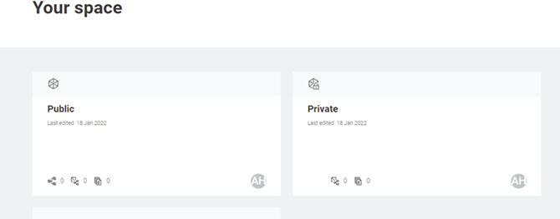

***Actual Result-*** The above mention section is displayed in the application.

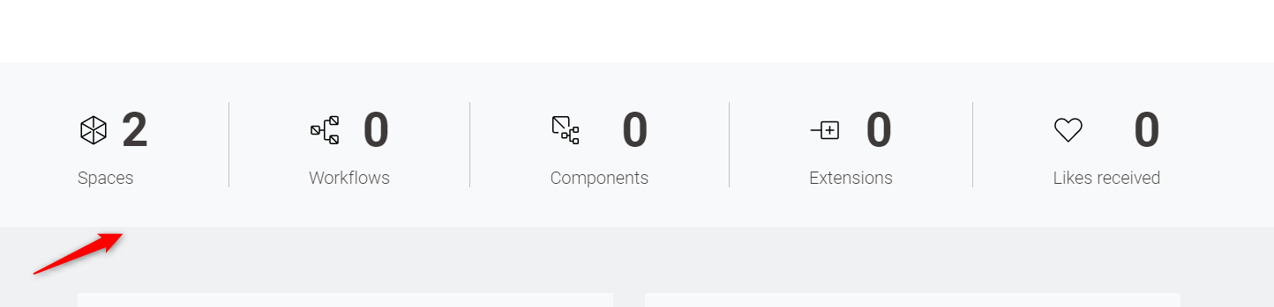

**Bug 2**

***Description***- Incorrect Title of the page.

***Expected Result***- As per the screenshot provided the heading displayed is “Your Space”.

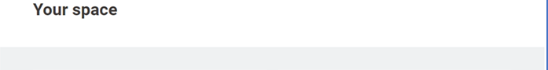

***Actual Result***- Currently the Heading is being displayed as “Your Spaces”



**Bug 3**

***Description***- Private Public spaces position being interchanged

***Expected Result***- As per the screenshot provided first **Public** space then **Private** space should be displayed.

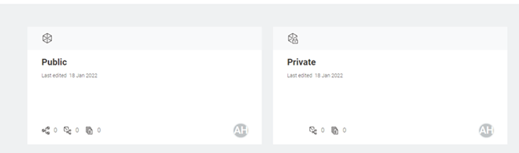

***Actual Result***- The position of both the spaces have been interchanged.

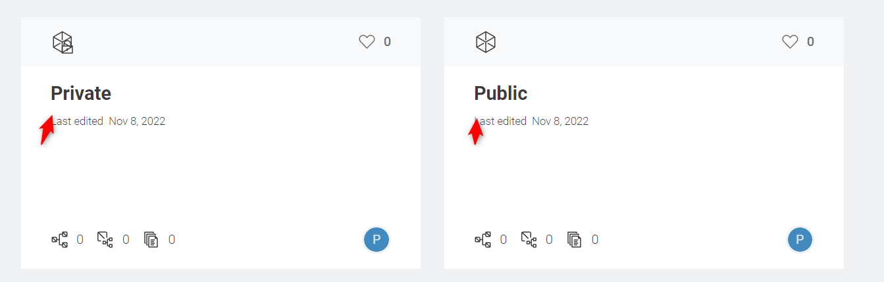

**Bug 4**

***Description***- Likes received image is displayed extra in Public and Private space

***Expected Result***- Likes received image should not be displayed for **Public** space and **Private** space.



***Actual Result****-* The likes received image is currently displayed for both spaces

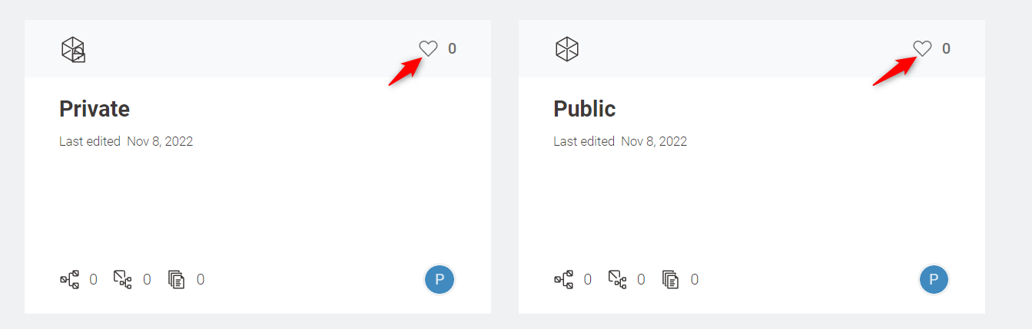

**Bug 5**

***Description***- Software Link is being displayed extra in Knime Open for Innovation section

***Expected Result***- Software link should not be displayed in Knime Open for Innovation section at the bottom of the page

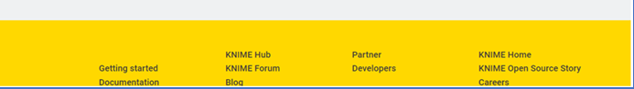

***Actual Result*-** Currently the link is visible and is clickable.

